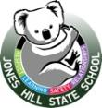
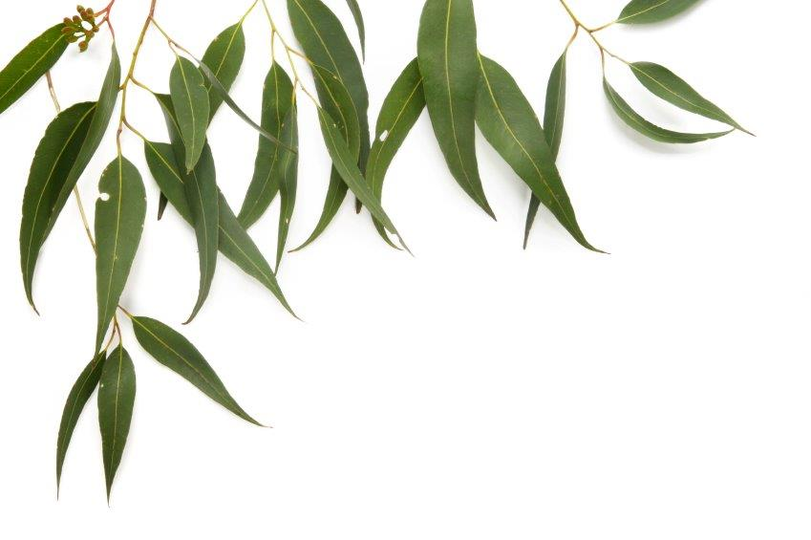
Jones Hill State School

UNIFORM POLICY

Wearing of the school uniform has many advantages to both students and teachers. It reduces peer pressure, raises school pride and assists in identification of our students on excursions and trips. Uniforms also help create an identity for the school within the wider community.

The Ministerial Statement to Queensland Parliament on 3rd March 1999. Determination of the Minister under Section 84(1)(g) of the Education (General Provisions) Act 1989. This procedure is designed to ensure compliance with the following legislation in Queensland:
- Anti-Discrimination Act,1991;
- Education (General Provisions) Act, 1989;
- Workplace Health and Safety Act, 1995;
- Workplace Health and Safety Act and Other Acts Amendment Act, 1990.

On Monday 13 October 2014, the P & C Meeting passed a resolution namely:
The P & C of the Jones Hill State School resolves that it supports a student dress code procedure for Jones Hill State School because it believes such a code promotes the objectives of the Education (General Provisions) Act 1989, and in particular that it:

- promotes a safe environment for learning by enabling ready identification of students and non-students of the school;
- promotes an effective teaching and learning environment by eliminating the distraction of competition in dress and fashion at the school;
- promotes a supportive environment at the school by fostering a sense of belonging;
- fosters mutual respect among individuals at the school by minimising visible evidence of economic, class or social
differences.

It is expected that the school uniform will be worn everyday:
- Attending or representing the school
- Travelling to or from school
- Engaged in school activities outside of normal school hours

Benefits of having a uniform policy
- Ease of identification of our students
- Fostering a sense of belonging at Jones Hill State School
- Developing mutual respect amongst students by minimising visible evidence of economic or social differences.

Consequences for breach of the Uniform Policy include
- Discussion with students re Jones Hill SS Uniform Policy
- Verbal request to make necessary changes
- Detention in Reflection Room
- Contact with parent/caregiver
- Withdrawal from relevant school activities

School Dress Code Guidelines
The Jones Hill School community, through a consultative collaborative process, has determined that
(a) the preferred options for all students are in the designated colours which formalise the uniform, and
(b) the school dress code procedures as outlined below.
(c) the uniform will not be altered to compromise the style, design or intended length.
Please note that the Jones Hill School community reserves the right to alter the school dress code policy.
(c) this policy will be revisited and revised in 2022.

BOYS & GIRLS:
Green polo shirt with school logo and black shorts with school initials (bike pants and short shorts are unacceptable, no denim clothing, no coloured clothing).
School dresses and skorts (Skirt with bike shorts attached) are also available for girls. White short socks and enclosed black shoes are worn with the uniform.
Black fleecy lined pullover / zip jackets are worn during winter, plain or with the school logo. Black tracksuit pants. Girls may wear black leggings under skorts. Skorts/shorts are not to be shorter than mid-thigh length.

Please name all items of clothing.

The sports polo shirt uniform is Yellow (Doran), Blue (McPaul) or Red (Radford) depending on which sports house students are allocated to. Coloured sports shirts can only be worn on days when school events involving sports houses are run.

Students not wearing correct uniform will not be eligible to attend school excursions and events.

Hats are compulsory. All children must wear a bucket/broad brimmed hat. Bucket hats (bottle green with reverse side showing sports house colour) are available for purchase as part of the uniform.
A “no hat, no play” policy is in place at Jones Hill State School – refer to Sunsmart Policy below or visit the link;
http://education.qld.gov.au/schools/healthy/wellbeing-guidelines/sun-safety.html

Shoes are compulsory for safety reasons. Closed-in lace up or velcro, nonslip shoes are to be worn. They should be black in colour. All other shoes are unacceptable.
Students wearing inappropriate footwear will be removed from play and activities due to health and safety reasons. http://ppr.det.qld.gov.au/education/management/Pages/Student-Dress-Code.aspx
http://ppr.det.qld.gov.au/education/management/Pages/Managing-Risks-in-School-Curriculum-Activities.aspx
https://www.legislation.qld.gov.au/LEGISLTN/CURRENT/W/WorkHSA11.pdf

If hair is touching the collar, then it must be tied back for both girls and boys. Hair needs to be pinned back off the face so as not to obscure vision. Hair styles should not be extreme and colour wise should look natural and promote a neat and sensible image. Hair styles considered to be distracting to learning environments are not permitted.
http://ppr.det.qld.gov.au/education/management/Pages/Managing-Risks-in-School-Curriculum-Activities.aspx http://ppr.det.qld.gov.au/corp/hr/workplace/Pages/default.aspx
http://education.qld.gov.au/schools/healthy/wellbeing-guidelines/head-lice.html

Inappropriate Dress

A student is inappropriately dressed if the student wears clothing or apparel that is, or could be deemed to be:
- offensive;
- likely to disrupt, or negatively influence the normal operation of the school;
- unsafe for the student or others;
- likely to result in a risk to the health of the student or others.
- bike shorts (unless under dresses).

Example:
- jeans or denim are inappropriate dress for school (unless allowed for special events),
- extreme fashion or gang wear,
- offensive motifs,
- apparel which infringes workplace health and safety conditions
- shoes which are not enclosed

Free Dress Days
Free dress days including swimming, sports and special days will be notified by notes home outlining requirements. Closed in shoes and sunsafe clothing is required at all times.
http://ppr.det.qld.gov.au/education/management/Pages/Student-Dress-Code.aspx
http://ppr.det.qld.gov.au/education/management/Pages/Managing-Risks-in-School-Curriculum-Activities.aspx

Makeup, fingernail polish and jewellery are not allowed, except for a watch and a single set of earrings in the form of sleepers or studs.

A student failing to wear the correct uniform may be subject to, but not limited to the following consequences:

Consequences for Uniform breaches
- An alternate piece of correct uniform will be offered to the student on a loan basis
- Representative activities withdrawn
- 20 minutes detention per offense
http://education.qld.gov.au/behaviour/detentions.html
http://ppr.det.qld.gov.au/education/learning/Pages/Safe,-Supportive-and-Disciplined-School-Environment.aspx
- Process – Letter to parents
– Meeting
- Uniform exemption card - If a student has a particular circumstance that requires special consideration for not wearing the school uniform a uniform exemption card will be issued from an administration member.

